This is much more distinctive!

I think we can find a middle ground

If we completely ignore TDC3, we obtain a really good alignment

Pairwise alignment between 2 and 3, works very well, revival agreed

Alignmend pairwise 01, 12, 23, 34 in alive region and 01, 12, 24 in unaligned region, we lose alignment of TDC2 and TDC3

It seems like the entire breakage is purely induced by TDC3, hence, we change it so that if it is TDC3, it only updates itself when compared with the rest.

So Attempt to align everything like this, but now when TDC3 is alive, you compare TDC3 with other TDCs using single adjustment method, (only adjusting singles)

Functioning well until when TDC3 is broken, we go into oscillation between TDC2 and 4

01,12,23,34 in unbroken region used, 01, 12, 24 in broken region used. We made sure that in any comparison with TDC3 was done, instead of chaining the alignment, we align the single TDC, this caused a better alignment.

The software becomes a lot more unstable as time goes on. Especially the relation between TDC4 and the rest of the TDCs

It appears that any TDC have this problem. And possible at around 1.8 to 1.9 it happened to TDC0 possibly as well\

seems like its fine

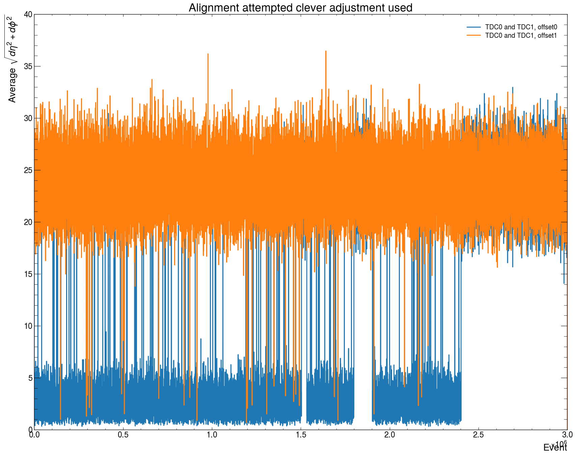

Most interesting bit: it seems like miusalignment happen in bursts. When a burst of misalignment happens, it typically requires 3-15 chunks of realignment to successfully bring it back (Which cause the spikes in the regions).

Especially TDC3 and 4, they really struggled, and this is the reason why it is extremely slow to align them.